**COMET BAY COLLEGE**

**Physics Unit 4 – Task 8**

**Light Waves Validation Test**

**Name: Total Marks /40**

**Part A** has to be handed in at the **commencement** of this test.

Standard school penalties apply for not meeting the deadline.

|  |  |
| --- | --- |
| Part A | /10 |
| Part B | /40 |
| Total | /50 | % |

1. Reflecting back on the experiment you completed what did the trend of your experiment suggest about the relationship between the density of the medium and the velocity at which light travels through it. (1 mark)

___________________________________________________________________

1. Assuming that the slit of light was perfectly aligned with the medium, that is the entry point had a tangent perpendicular to the normal, discuss two errors and in detail, how they would affect the results. (4 marks)

_____________________________________________________________________________________________________________________________________________________________________________________________________________________________________________________________________________________________________________________________________________________________________________________________________________________________________________________________________________________

1. Using your knowledge of Snell’s Law and refraction explain how this type of experiment could be relevant to the real world and improve society. (4 marks)

__________________________________________________________________________________________________________________________________________________________________________________________________________________________________________________________________________________________________________________________________________________________________________________________________________________

A group of students in your class (Bob, Chris and Beccy) are also conducting an experiment similar to yours. However, instead of light passing through different mediums of different densities they are passing different coloured lights through the one medium – glass.

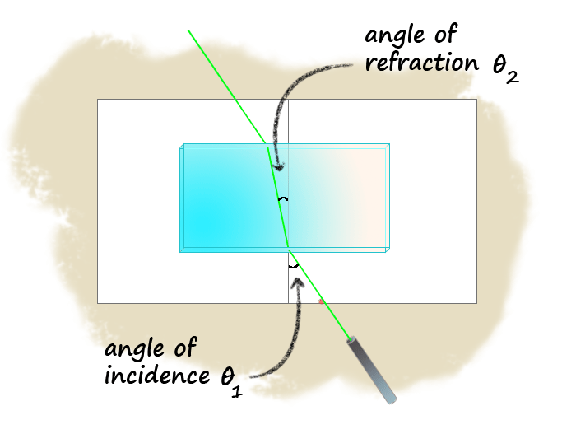

$\frac{sin θ_{i}}{sin θ_{r}}$**= $\frac{v_{i}}{v_{r}}$ = $\frac{λ_{i}}{λ_{r}}$ = $\frac{n_{r}}{n_{i}}$**

**Figure 1: Showing the green light passing through the glass medium**

1. Explain how wavelength and velocity are linked in relation to your understanding of electromagnetic radiation. (3 marks)

__________________________________________________________________________________________________________________________________________________________________________________________________________________________________________________________________________________________________________________________________________________________________________________________________________________

They have selected 5 LED laser lights, all of known frequencies.

Speed of electromagnetic radiation in air is calculated to be vair = 2.98964 x 108 m s-1.

The following results were recorded.

1. Complete the table of data. (working space below table ) (2 marks)

**Table 1: Laser lights and their known frequencies in air.**

|  |  |  |
| --- | --- | --- |
| Laser light colour | Frequency in air (THz) | Wavelength  (nm) |
|
| Blue | 610 |  |
| Green | 580 |  |
| Yellow | 515 |  |
| Red | 460 |  |

1. The students completed their experiment and the averages were recorded below.

(6 marks)

**Table 2: Wavelength and Percentage uncertainties of laser lights.**

|  |  |  |  |  |  |  |
| --- | --- | --- | --- | --- | --- | --- |
| Light Colour | Practical **θi** | Practical **θr** |  | %uncertainty | Wavelength in air (nm) | Wavelength in glass (nm) |
| Blue | 59 | 34 |  |  |  |  |
| Green | 65 | 37 |  |  |  |  |
| Yellow | 42 | 27 |  |  |  |  |
| Red | 53 | 34 |  |  |  |  |

1. Calculate $\frac{sin θ_{i}}{sin θ_{r}}$ and fill this in in the table above. Show working for the blue light in the space below. (1 mark)
2. Assuming the students used a similar protractor to the one you used with one degree graduations, calculate the percentage uncertainty for $\frac{sin θ_{i}}{sin θ_{r}}$. Show working for the blue light in the space below. (2 marks)
3. Calculate the wavelength in glass. Show working for the blue light in the space below. (1 mark)

________________________________________________________________________

Room for working on other problems the next page

(Anything written in this section will **not** be marked)

1. Plot $\frac{sin θ_{i}}{sin θ_{r}}$ of the varying light versus the wavelength in air. Include the uncertainty. Ensure that the range for the $\frac{sin θ_{i}}{sin θ_{r}}$ extends to 1.7 on the designated axis And that wavelength starts at 250 nm. (6 marks)

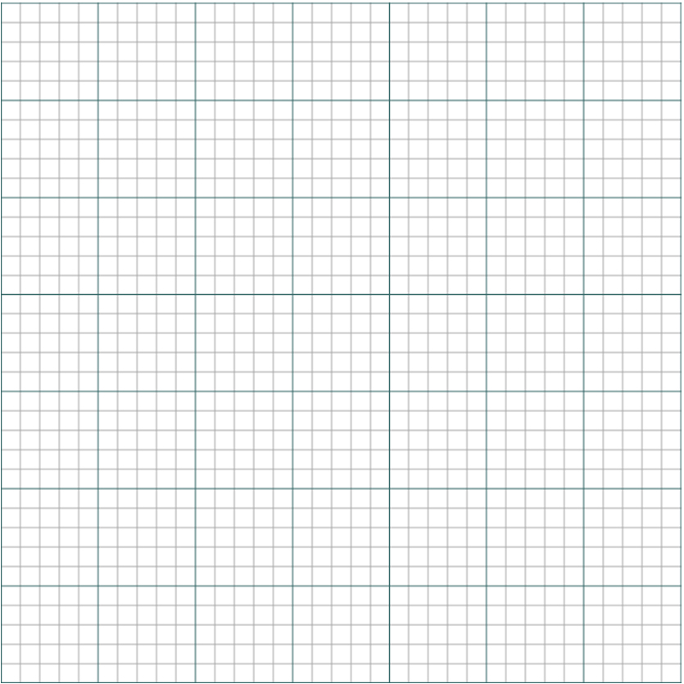

1. Now there teacher gets them to put on these special blue glasses and test another light. The blue glasses make the laser light look bright white, but this is not its true colour. The students determined that at an average angle of incidence of 35o produces an average angle of refraction of 20o.

Use your graph and data sheet to determine the colour of the laser light. Show all necessary calculations and logic.

NOTE air has a refractive index of 1.0027 and in a vacuum the refractive index is 1. (5 marks)

1. What is an appropriate aim for this experiment (2 marks)

______________________________________________________________________________________________________________________________________

1. Complete the following:
2. Independent Variable: (1 mark)

________________________________________________________________

1. Dependent Variable: (1 mark) ________________________________________________________________
2. Controlled Variables: (1 mark) ________________________________________________________________________________________________________________________________